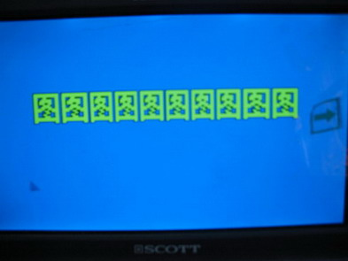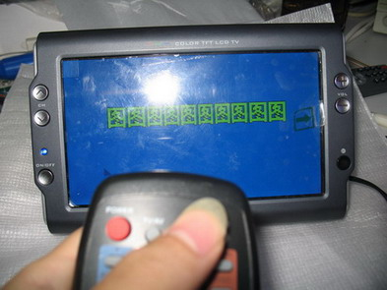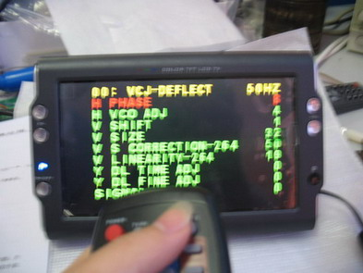
1.Turn on the unit.
2. Press SET1 to enter factory setting menu
3.Press MENU to enter Page 00 . Press▲▼ key to move up and down, ◄►key to adjust.(Operation are the same in following adjustment.

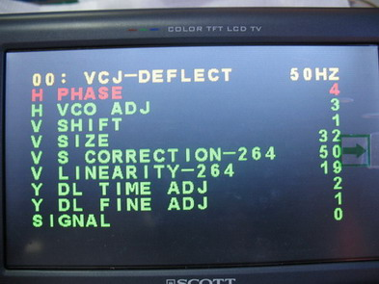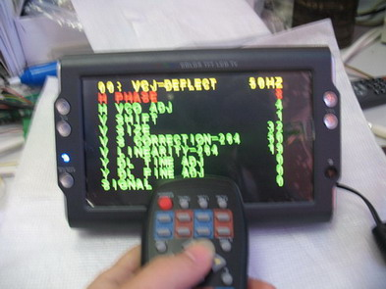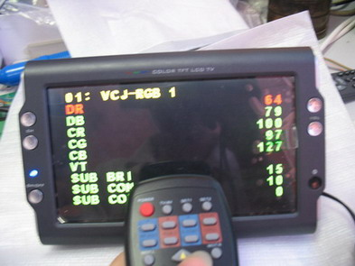
5. Press Menu key to flip page down.
4. Ok 00 page for reference.
6.Enter 01 page

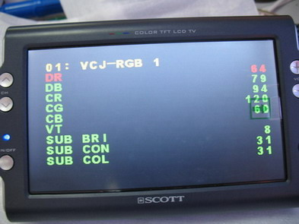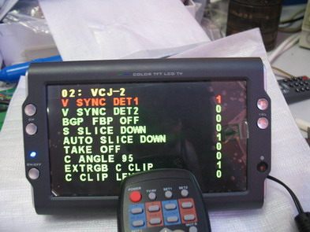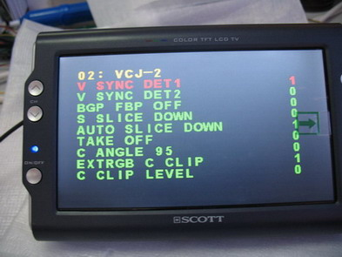
7.OK 01 page for reference.
8.Press MENU to enter 02 page.
9. OK 02 page for reference.

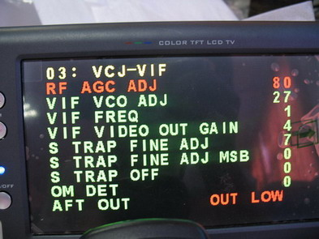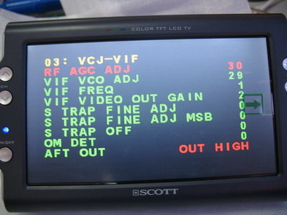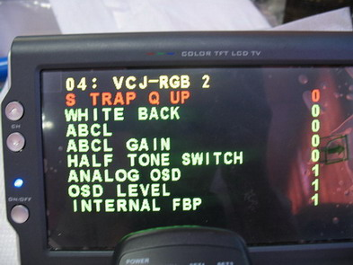
10.Press MENU key to enter 03 page.
11. OK 03 page for reference.
12. Press MENU key to enter 04 page.

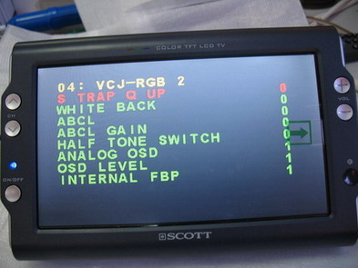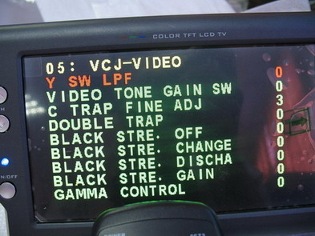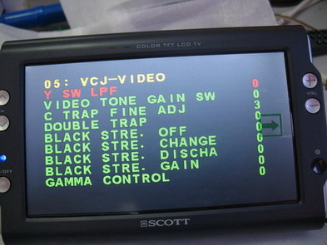
13. OK 04 page for reference.
14. Press MENU to enter 05 page.
15. OK 05 page for reference.

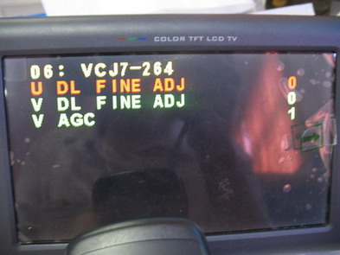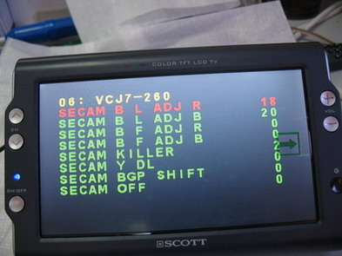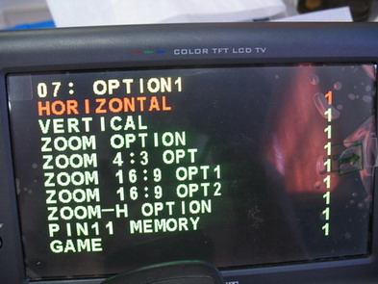
16. 06 page for reference or see 17 page.
17. OK 06 page for reference.
18. Press MENU to enter 07 page and adjust.

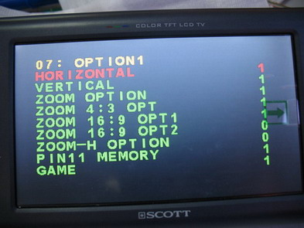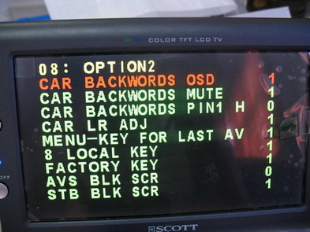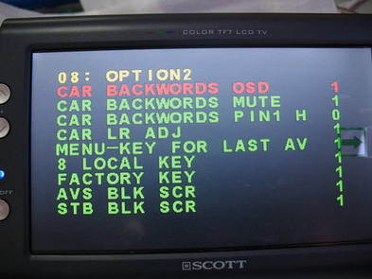
19.OK 07 page for reference.
20. Press MENU to enter 08 page and adjust.
21. OK 08 page for reference.

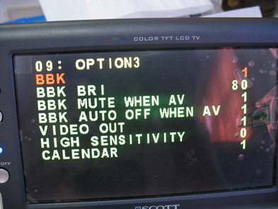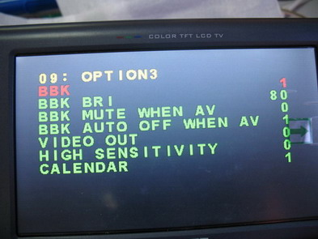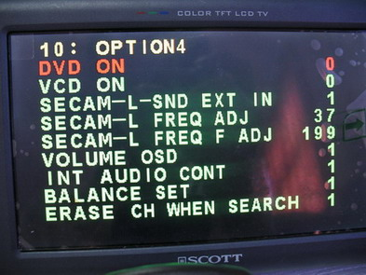
22. Press MENU to enter 09 page.
23. OK 09 page for reference.
24. press MENU to enter 10 page.

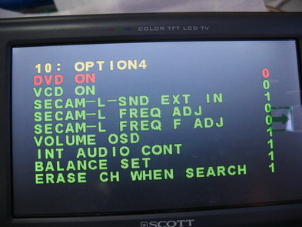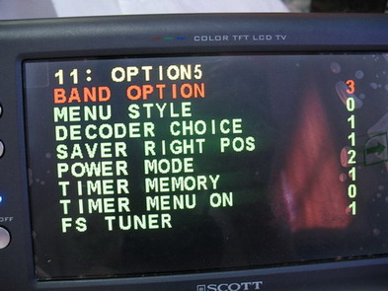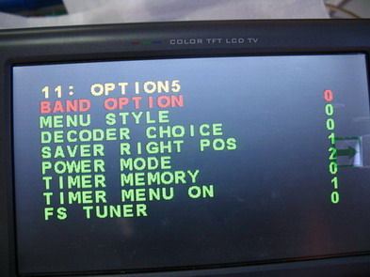
25. OK 10 page for reference.
26. Press MENU to enter 11 page and adjust.
27. OK 11 page for reference.
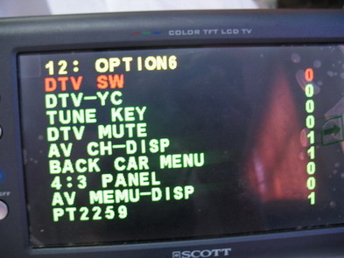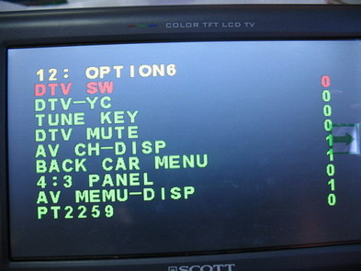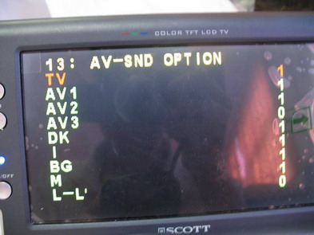
28. Press MENU to enter 12 page and adjust.
29. OK 12 page for reference.
30. Press MENU to enter 13 page and adjust.

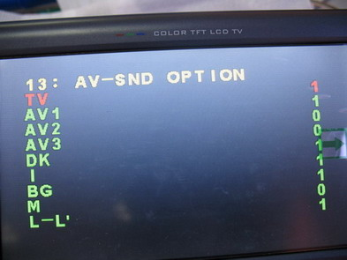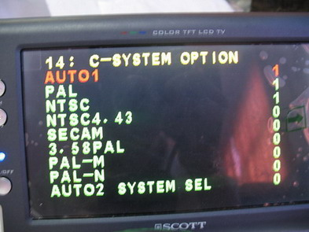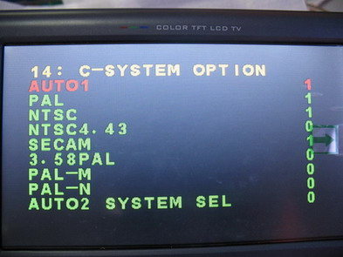
31. OK 13 page for reference.
32. Press MENU to enter 14 page and adjust.
33. OK 14 page for reference.

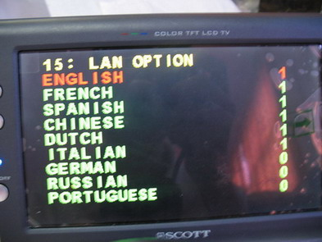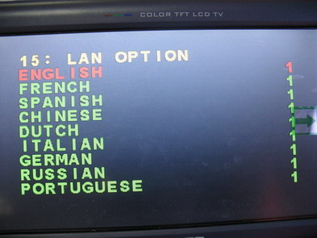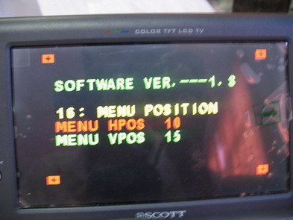
34. press MENU to enter 15 page and adjust.
35. OK 15 page for reference.
36. press MENU to enter 16 page and adjust.
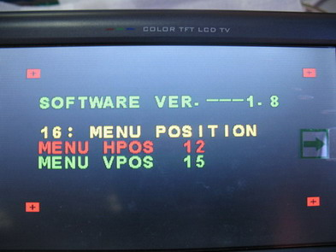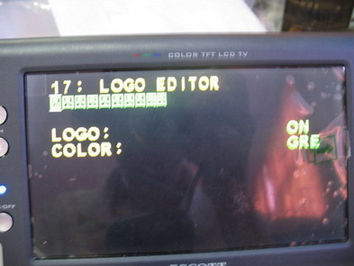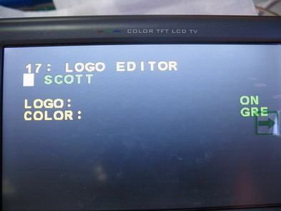
37. OK 16 page for reference.
38. Press MENU to enter 17 page and adjust
39. OK 17 page for reference.

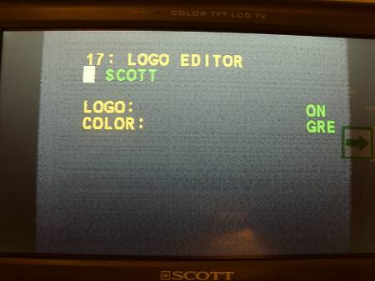
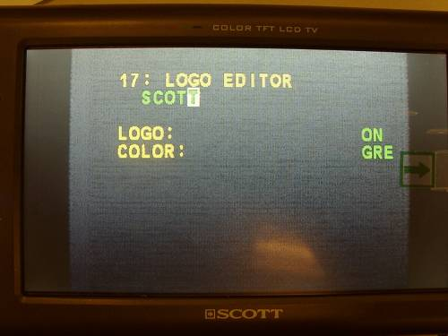
41. Press ▼ key, the cursor move from left to right and press ▲ key, the cursor move from right to left.
40, Press MENU key to enter 06 page
42. Press ▼ key, the cursor move from left to right and press ▲ key, the cursor move from right to left.
and adjust

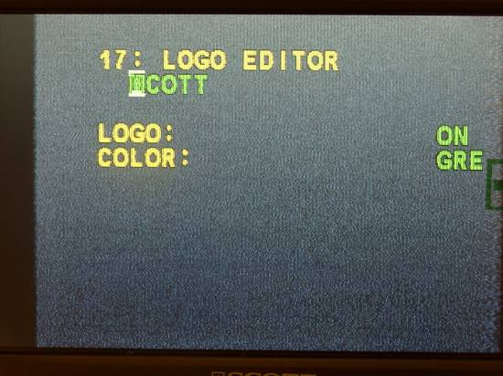

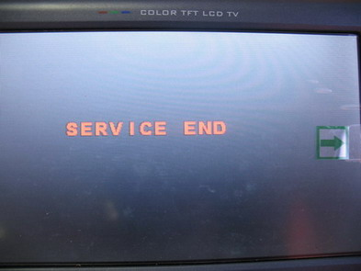
43. Page 18 finish adjust and press POWER key to EXIT adjust.

Press ◄►key to select text for LOGO

